HGV TECHNICIAN



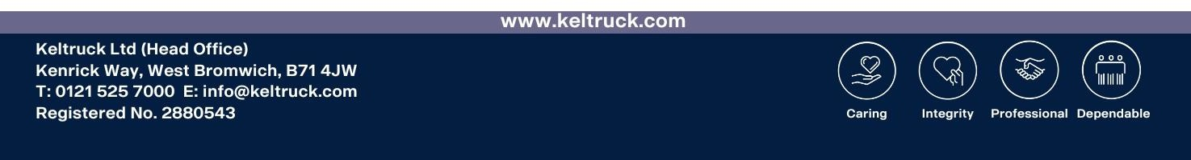
Location: Worksop
Hours: Monday to Friday – 40 hours
Alternate Shifts:06.00am-14.00pm and 14.00pm-22.00pm
Alternate Saturdays: 6am – 12pm @ Overtime

Job Description

The position is for a HGV Technician with prior experience in the field or a transferable field, responsible for maintaining commercial vehicles, trailers and industrial power solutions to UK legislation standards and Scania manufacturer specification requirements.

You will be required to apply your previous experience to the role, whilst learning new information and skills through training on the Scania product. Becoming embedded within our team and providing our customers with excellent maintenance and diagnostic capabilities. Working with wider departments to identify priorities and communicate with customers.

Person Specification

Using your excellent problem-solving skills and attention to detail to support the premium heavy goods vehicle in the market. Previous experience in a similar environment would be ideal but is not essential.

We are looking for someone who is caring, displays integrity, is dependable and professional in their approach to working within our team and on our customers’ vehicles. Utilising diagnostic equipment to identify faults and workshop literature to ensure manufactures procedures are followed.

Completing accurate paperwork to ensure compliance responsibilities are upheld. Applying our training to ensure a health and safety conscious approach is applied and a clean work environment is maintained.

A car and HGV driving license are ideal but not essential. Displayed prior experience (3 years minimum) or a relevant qualification to the role are required (Level 3 NVQ or City and Guilds)

Our Great People, Get More

- 25 days annual leave plus bank holidays which increases with length of service
- Fully expensed manufacturer training with career pathways
- Team Social Bonus based on overall Branch performance
- General joining bonus (T&Cs apply)
- Specific Technician joining bonus (T&Cs apply)
- Refer a friend scheme to incentivise bringing other people to the business
- Length of service awards, (extra pay, holidays and pension from Keltruck)
- Pension scheme (increase contribution options)
- Employee assistance program, access to doctors and support for you and the family
- Market leading employee platform for staff information, household savings and support
- Life insurance (often referred to as a death in service policy)
- Other elements such as free uniform, parking, warm drinks, Easter eggs and shopping vouchers

How To Apply

Call Thomas Sadler on 07733 318136
Or submit you interest to Thomas.sadler@keltruck.com
Alternatively, send your CV and position you wish to apply for to careers@keltruck.com

