Accounts Administration Trainee/Apprentice



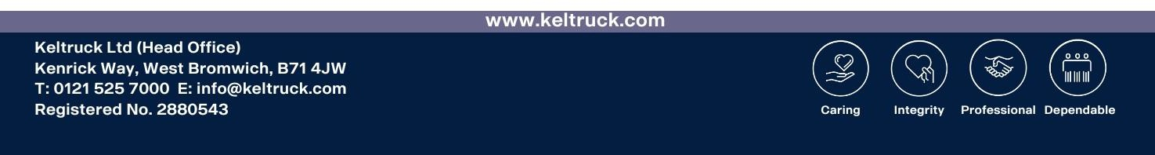
Location: West Bromwich
Hours: 08:30 – 17:00 Monday to Friday. 1 hour unpaid lunchbreak
Alternate Shifts: No
Alternate Saturdays: No

Job Description

Working within the Keltruck Accounts Department, the position is for someone who will assist with a wide variety of tasks to support the day-to-day operations of the accounts department. Providing high levels of data entry accuracy, a willing to learn through active listening and effective questioning and fostering strong working relationships.
Showing initiative by actively engaging with tasks, taking on additional responsibilities and supporting colleagues to achieve team objectives. The position also requires someone who can maintain a clean working area and has excellent person presentation.

Person Specification

An organised and detail-focused individual with an interest in accounts and finance. Able to work accurately with numerical and financial data, with good attention to detail and a willingness to learn new systems and processes.

A proactive team member who takes initiative and gets involved with tasks. Able to manage priorities, meet deadlines and work both independently and as part of a team.

Good communication and interpersonal skills, with the ability to ask questions, seek clarification and keep the team updated on progress. Reliable, professional and committed to developing knowledge and skills within an accounting environment.

The person must always comply with our Health and Safety standards and will be expected to attend any training as required. Therefore, a car driving license would be preferred but again is not essential.

Our Great People, Get More

- 25 days annual leave plus bank holidays which increases with length of service
- General joining bonus (T&Cs apply)
- Refer a friend scheme to incentivise bringing other people to the business
- Length of service awards, (extra pay, holidays and pension from Keltruck)
- Pension scheme (increase contribution options)
- Employee assistance program, access to doctors and support for you and the family
- Market leading employee platform for staff information, household savings and support
- Life insurance (often referred to as a death in service policy)
- Other elements such as free parking, warm drinks, Easter eggs and shopping vouchers

How To Apply

Submit you interest to (adam.ross@keltruck.com)
Alternatively, send your CV and position you wish to apply for to careers@keltruck.com

